ADD MODEL (

1Select a ModelType,

2 Type a model name in

3, click add model) finished

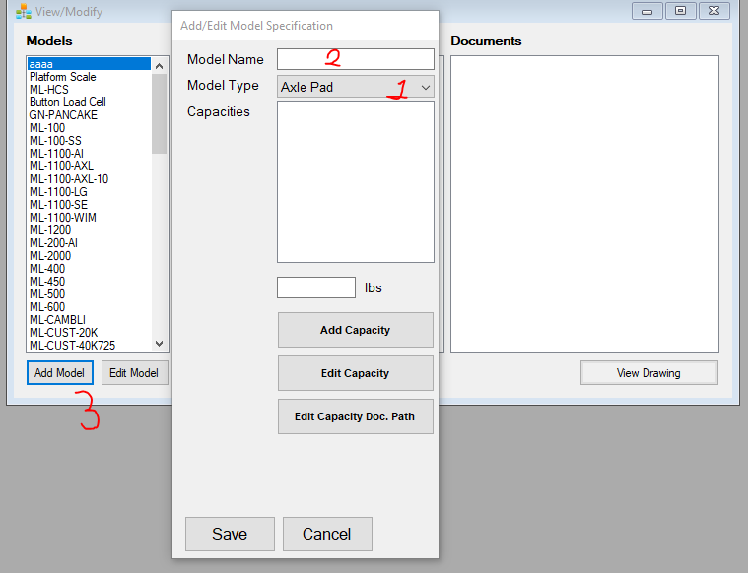

ADD CAPACITY (which is ADD Model Now Model Version

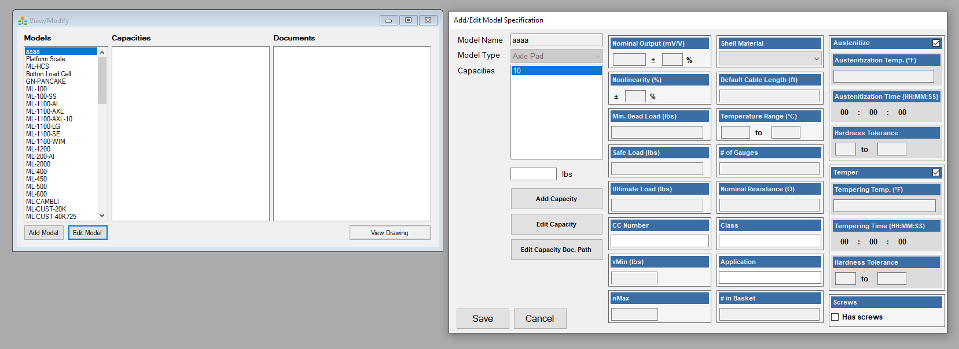

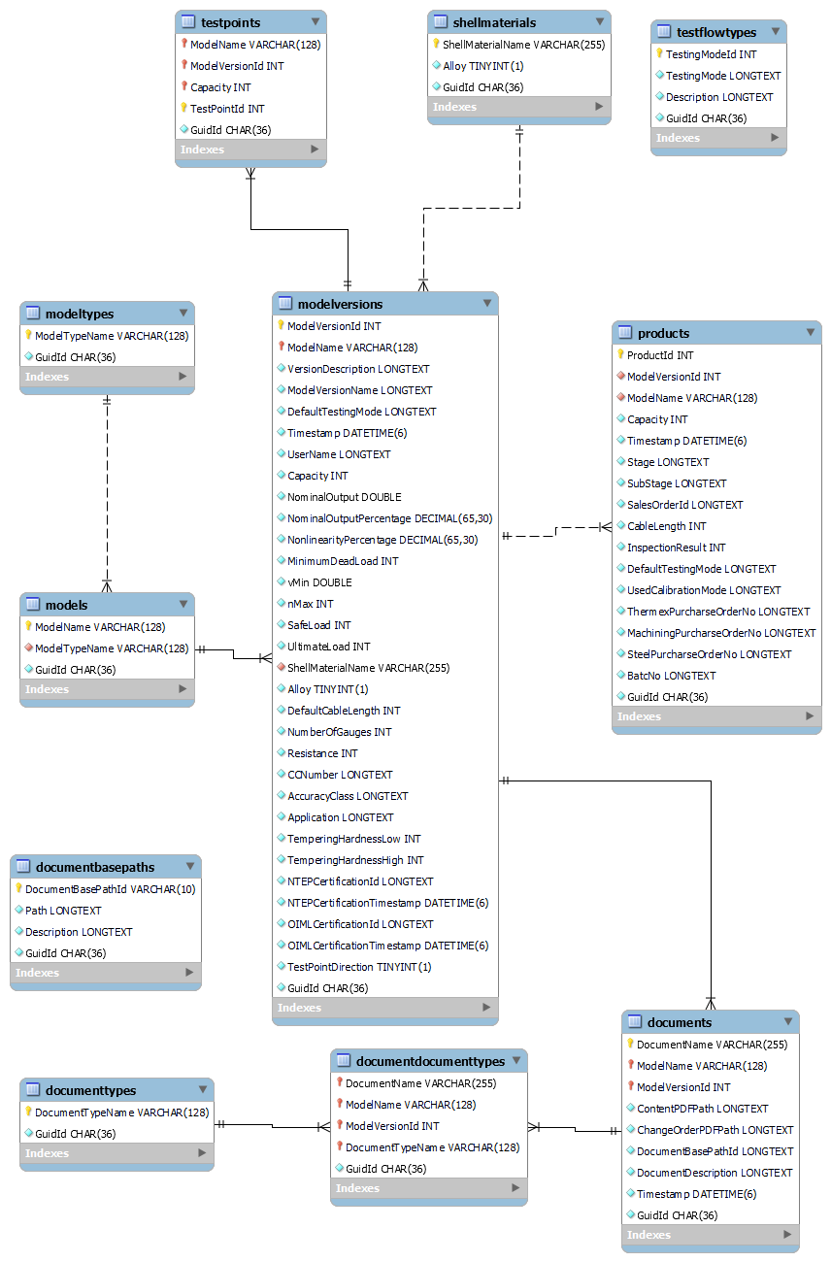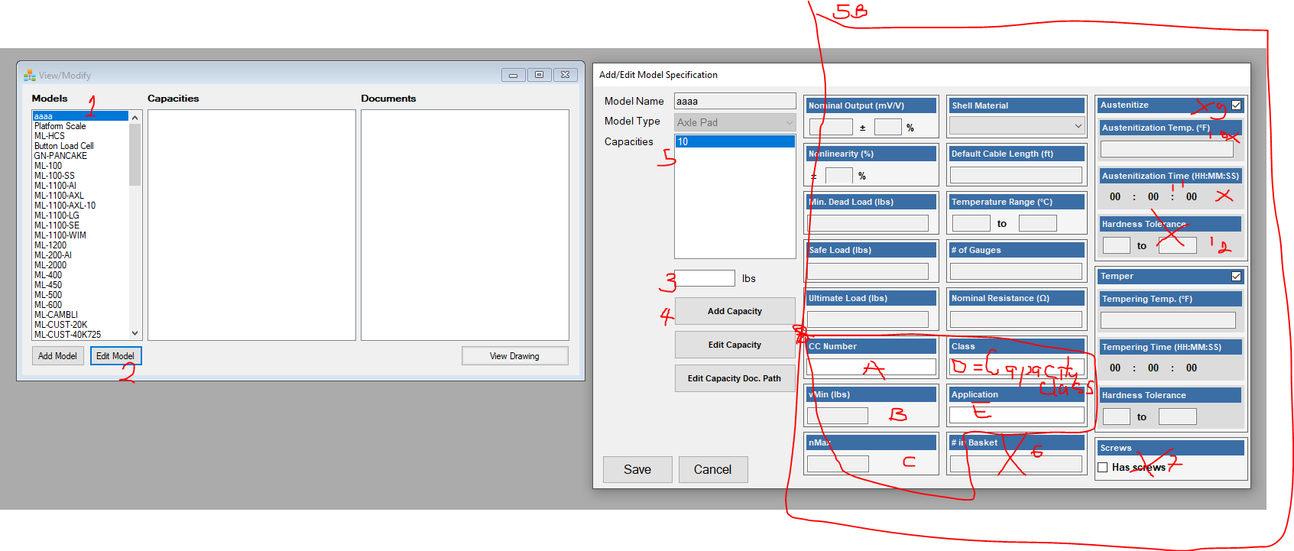

1 Select Model 2. Click Edit 3. Add Capacity in pounds 4.Cllick Add capacity 5.Select the capacity , then

5B pops out , fill these and click save

To adapt now to current massfussion 2.0

ModelVersion == Add Capacity and we don’t add several capacity for a therefore we will just create a new version with the definition below but the crossed out ccomun are no longer present as we can see from 8,

Additionally, the 5 specification items that we wanted to label are: title 🡺“NTEP

* CC Number vMin nMax Class Application
* ADD TestPoints( these are weights